What is Hive ?

Apache Hive is a popular SQL interface for batch processing on Hadoop. Hadoop was built to organize and store massive amounts of data Hive gives another way to access Data inside the cluster in easy, quick way.

Hive provides a query language called HiveQL that closely resembles the common Structured Query Language (SQL) standard. Hive  was one of the earliest project to bring higher-level languages to Apache Hadoop. Hive Gives ability to Analysts and Data Scientists to access data with out being expert in Java . Hive gives structure to Data on HDFS making it data warehousing platform. This interface to Hadoop not only accelerates the time required to produce results from data analysis, it significantly broadens who can use Hadoop and MapReduce. Let us take a moment to thank Facebook team because Hive was developed by the Facebook Data team and, after being used internally, it was contributed to the Apache Software Foundation .Currently Hive is freely available as an open source software from Apache.

SQL for Hadoop

HQL # No need to be expert in Java

Easier to Learn and Many People Know already

Structure to Data on HDFS

Thank you Facebook

Open Source Project managed by ASF

.Apache Hive is a popular SQL interface for batch processing†on Hadoop... As we all know, Hadoop was built to organize and store massive amounts of data† . Hive gives another way to access Data inside the cluster in easy, quick way.

Hive provides a query language called†HiveQL†that closely resembles the common†Structured Query Language†(SQL) standard. Hive †was one of the earliest project to bring higher-level languages to Apache Hadoop. Hive Gives ability to Analysts and Scientists to access data with out being expert in Java . Hive gives structure to Data on HDFS making it data warehousing platform. This interface to Hadoop not only accelerates the time required to produce results from data analysis, it significantly broadens who can use Hadoop and MapReduce. Let us take a moment to thank facebook team because Hive was developed by the Facebook Data team and, after being used internally, it was contributed to the Apache Software Foundation .Currently Hive is freely available as an open source software from Apache.

Let us discuss used cases of Hive. Hive is typically used to place Large amount of unstrcured /Semi structured data on Hadoop and build Structure of it.. Hive is best suited for batch jobs over Large Set of data for example WebLogs, Network Router logs. Analysts would be able query data on Ad-hoc basis to Data Analysis. Stable Version of hive is 0.13

Ok now we know what is hive , Motivation for Hive and Used Cases of Hive , let us understand what Hive is not. Hive is not a Database

**Let us understand difference between RDBMS and HIVE**

RDBMS Stores Data, where as Hive uses Data which is on Hadoop and does not store actual data. RDBMS support for both OLTP AND OLAP , WHERE AS HIVE IS FOR OLAP. Hive in traditional is used for large scale volume. Hive is best suited for data warehouse applications, where there is no need for real-time responsiveness to queries are not required.

Hive looks very much like traditional database code with SQL access. However, because Hive is based on Hadoop and MapReduce operations Hive is more used for batch processing. Hadoop is intended for long sequential scans, and because Hive is based on Hadoop, you can expect queries to have a very high latency (many minutes). .Latency for hive queries is high for even for small jobs which means that Hive would not be appropriate for applications that need very fast response times.

In this Sample Table : if we want to delete SAM Rating on Documentary, in a RDBMS Table, we can run update/Delete command to Update/ delete it, where as in Hive we cannot update/Delete a particular value. This kind of transactions are not supported in Hive. But Hive supports Overwrite of the entire table or appending additional Data to this table. Let us proceed to discuss Hive Architecture.

Hive is not 100 % SQL. HQL is limited in the commands it understands. Not all SQL commands work on Hive, for example, Updates and deletes are not supported.

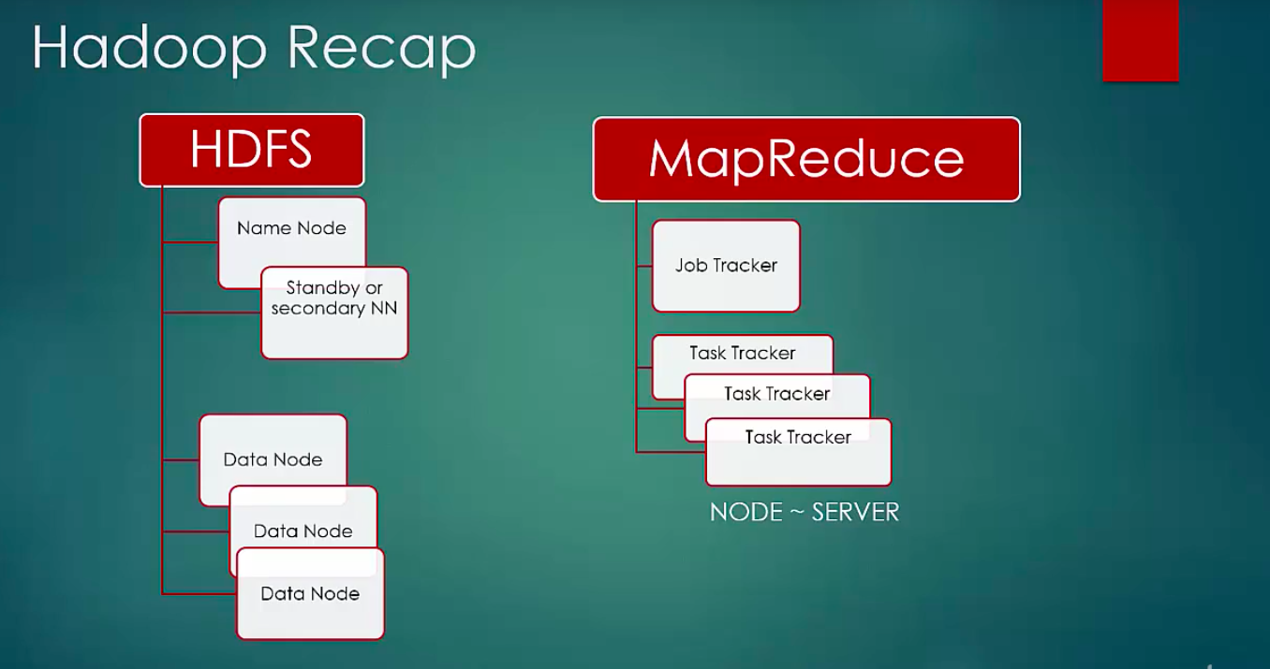

data is stores in data nodes and namenode manages metadata(data about data).whenever file is moved into hdfs , file is divided into blocks and blocks are replicated across data nodes based on replication factor.default replication factor is 3. Whenever a client tries to read the data namenode provides information on the blocks related to that data and client then will read the data from datanodes.

Map reduce -> jobs are submitted to job tracker and tasks are forwarded to task tracker.A task can either be map task or reduce task.

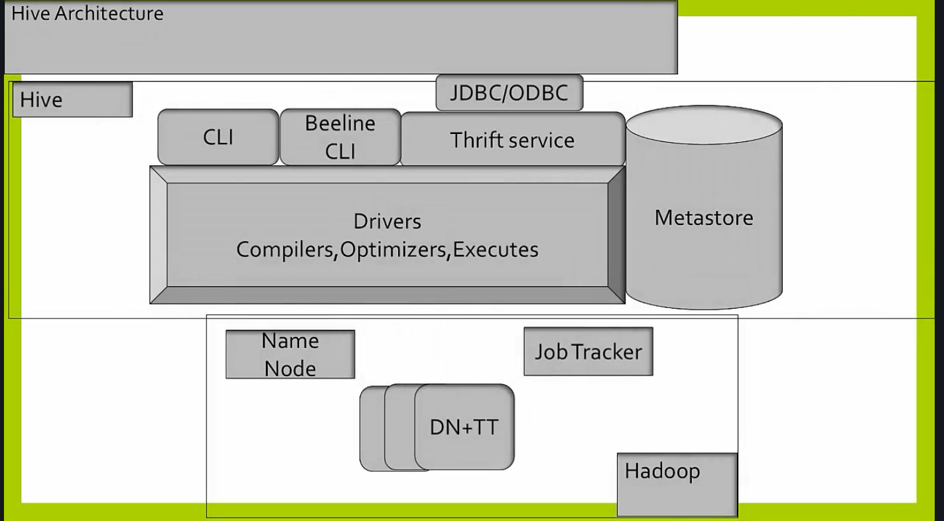

Thrift service :-This server exposes a very simple client API to execute hive query language standard.

Meta store :- stores meta data such as schema data , partition information.metastore distinguishes hive as a traditional data warehouse solution when compared to similar data processing systems also built on top of Hadoop like pig. Default meta store database is derby database . it does not provide concurrency for multiple users. Hence we should not use default embedded database for matastore . Wht should we use then for metastore ?

Any jdbc compliant database should be used as metastore. In practice MYSQL is implemented as metastore.

Drivers :- manage lifecycle of query language of statement during the compilation ,optimization and execution.

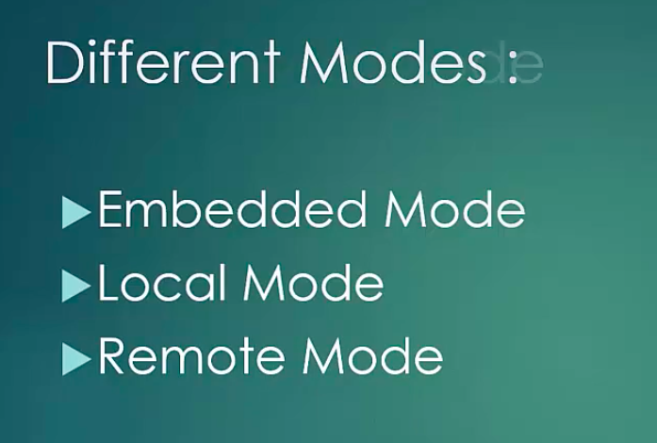

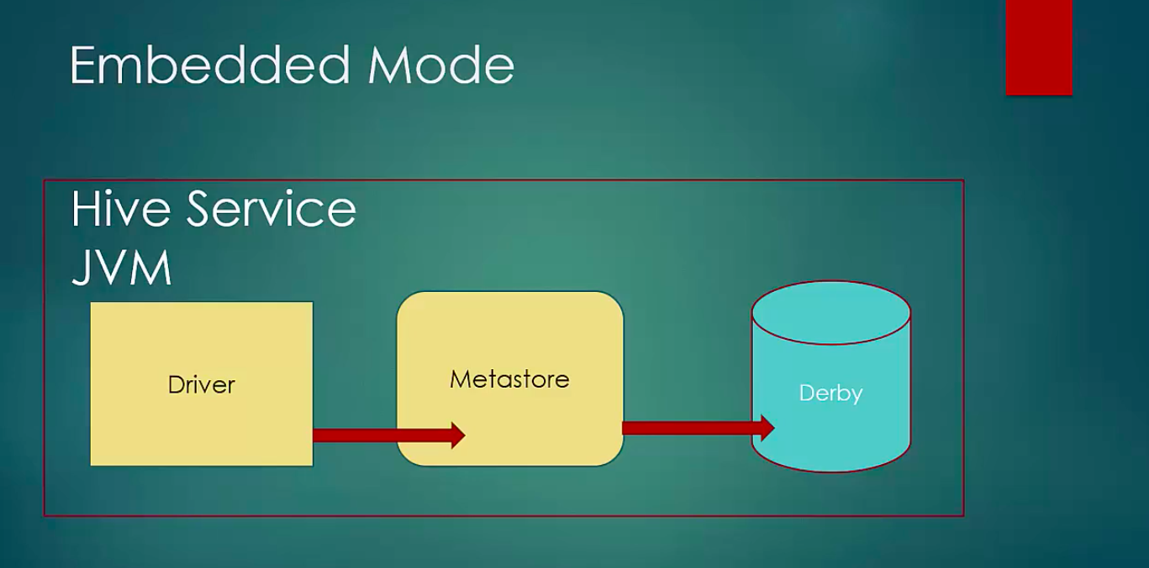

Will only support 1 user . Something which comes in VM or cloudera sandbox.

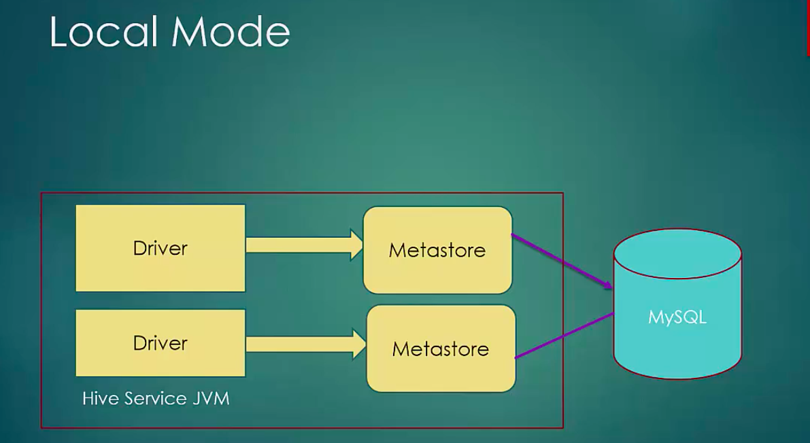

Mysql /metastore is outside JVM.

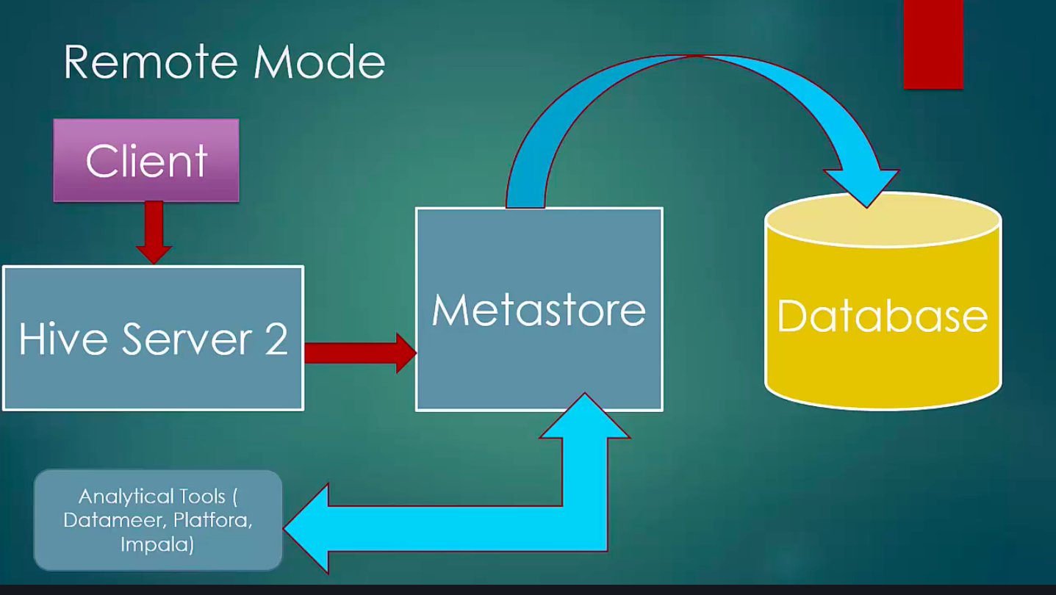

Recommended for Prod .

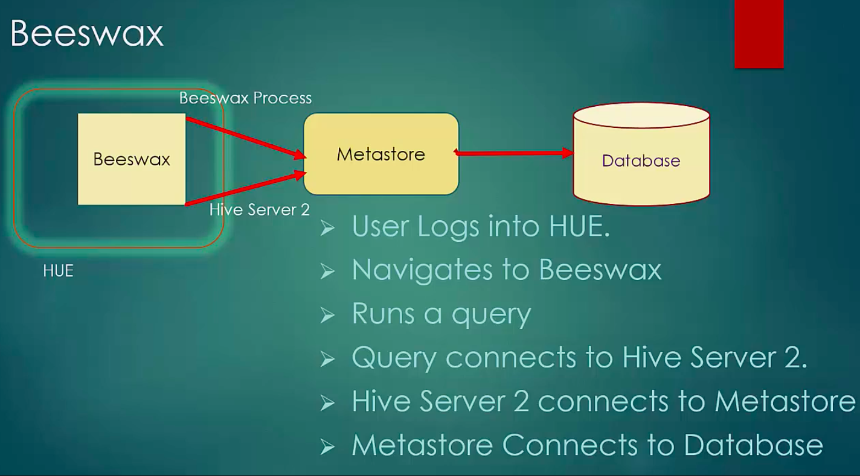

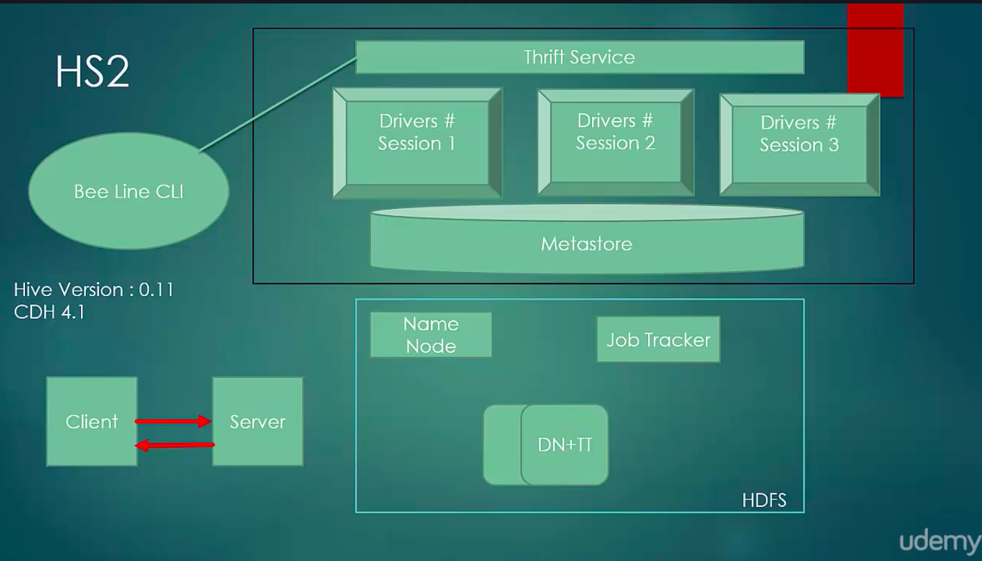

Hive server 2 brings in traditional client server architecture to run more users concurrently.

It also provides authentication through Kerberos or ldap. Hiveserver2 is available from 0.11 or cdh 4.1 version and later.it implements thrift based RPC which handles concurrent clients.It is a container for hive execution engine.

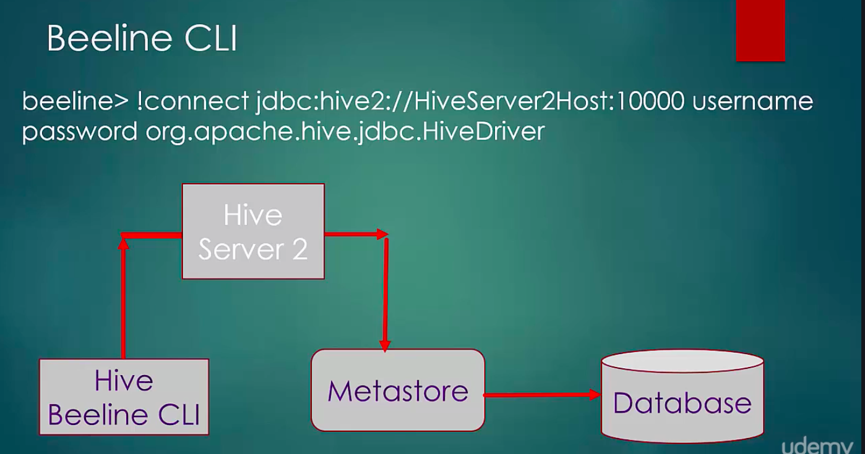

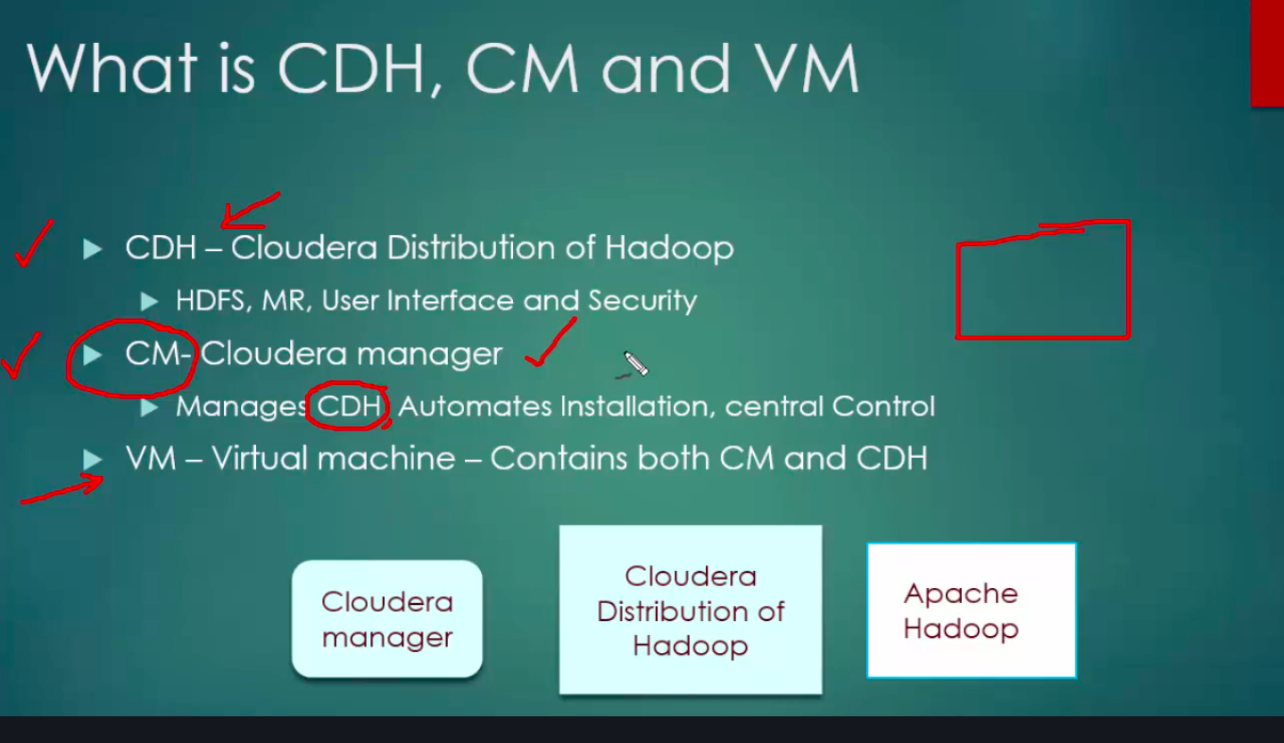

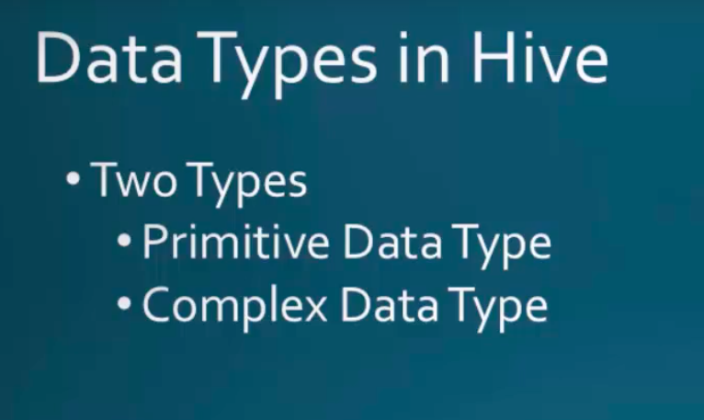

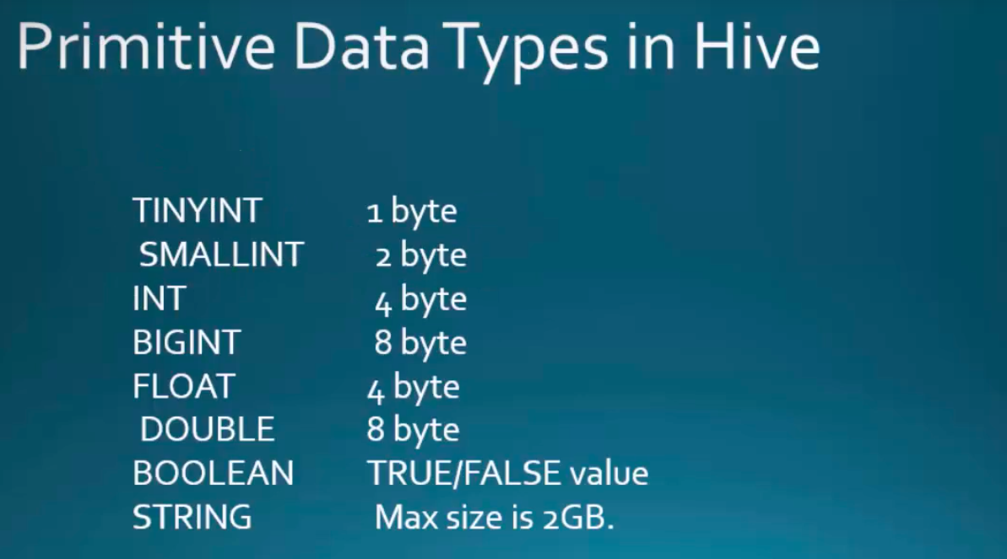

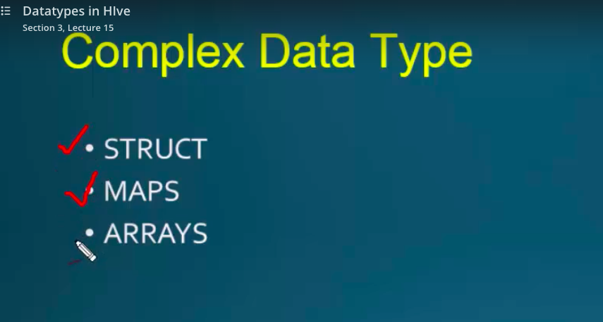

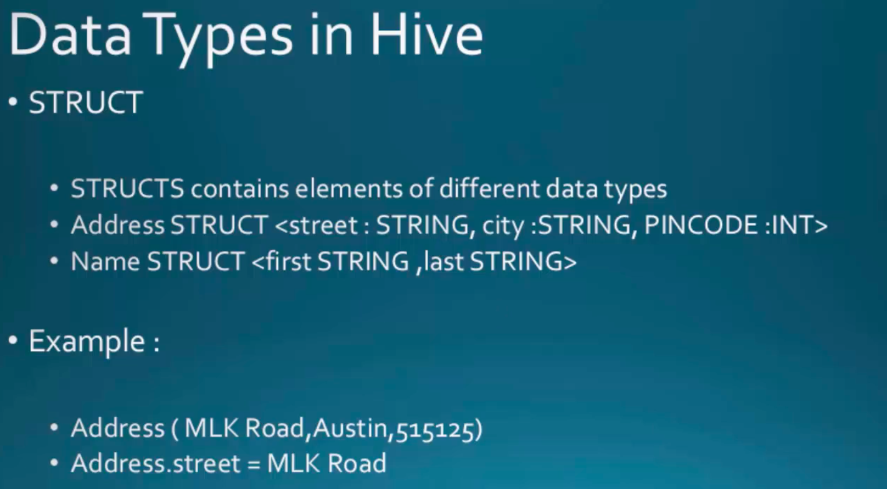

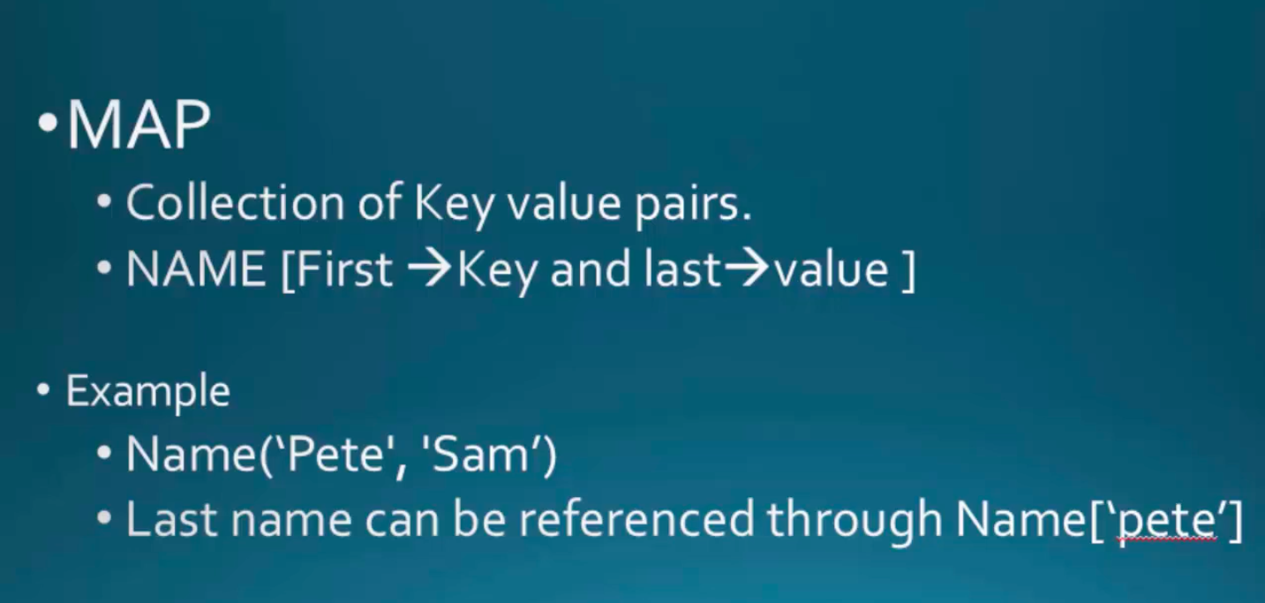

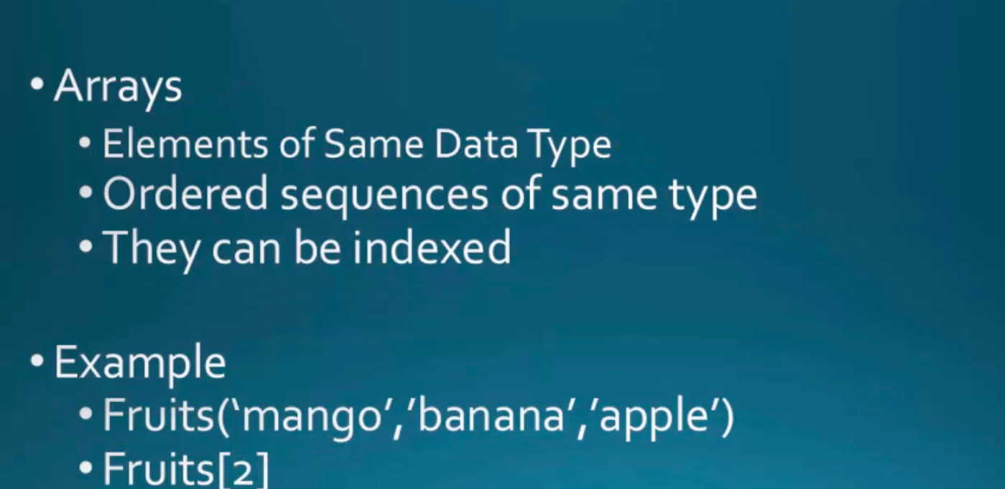

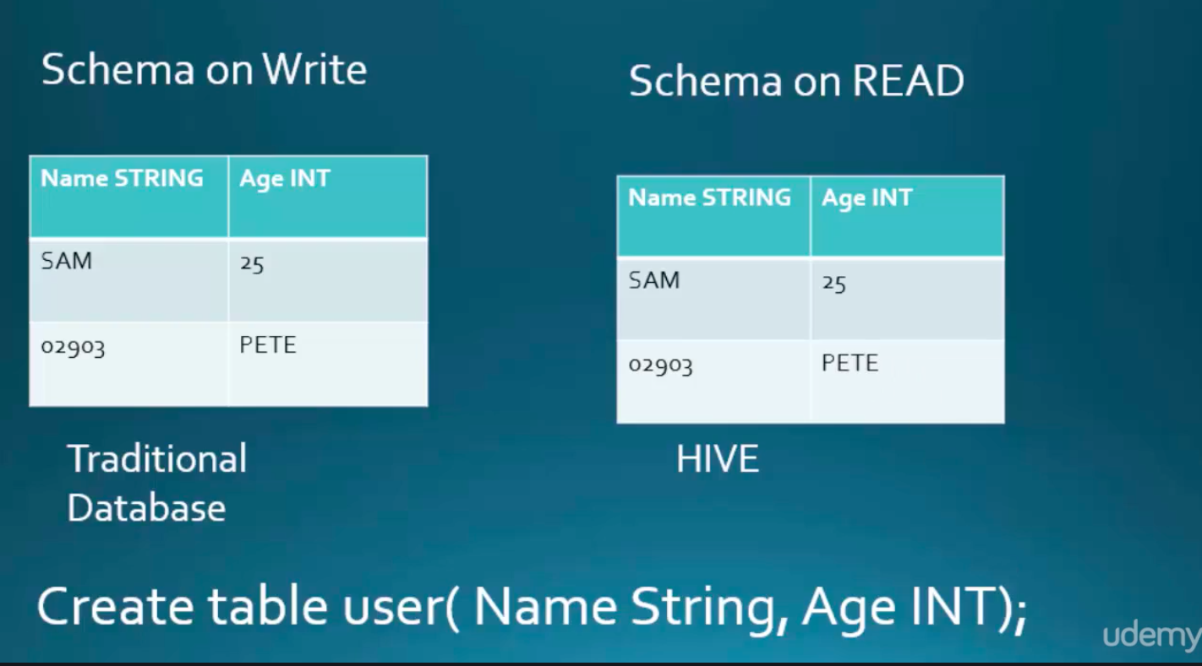

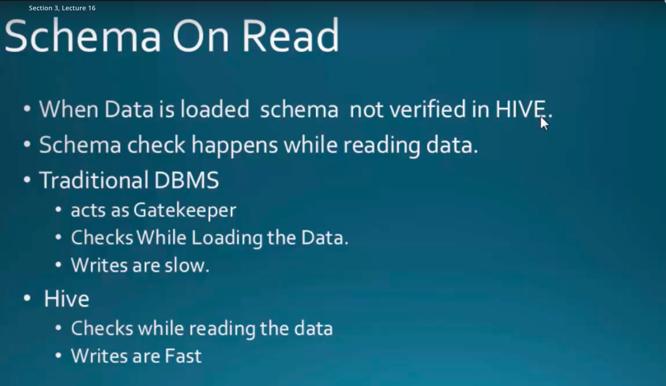

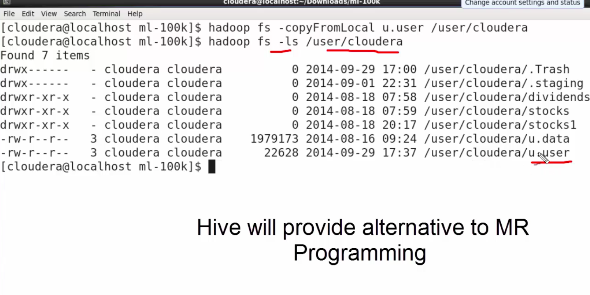



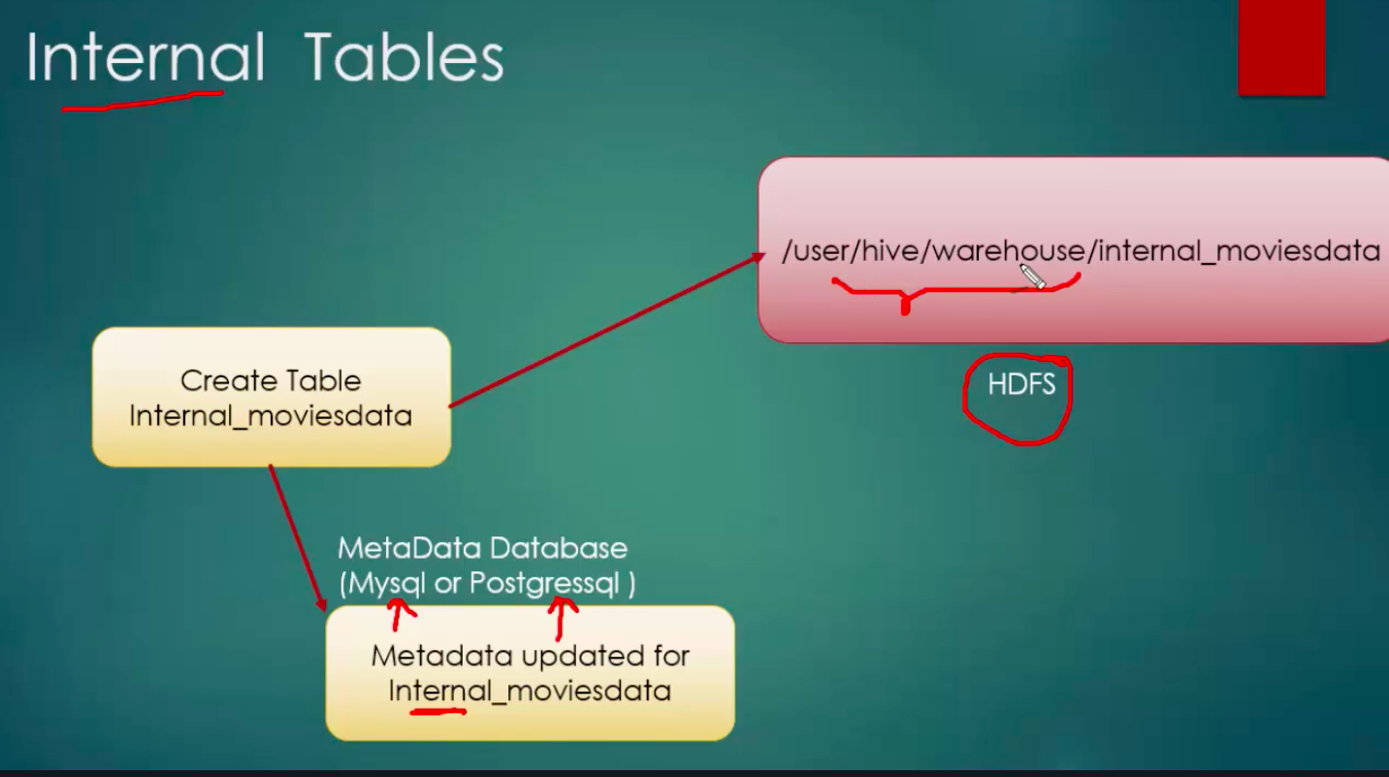

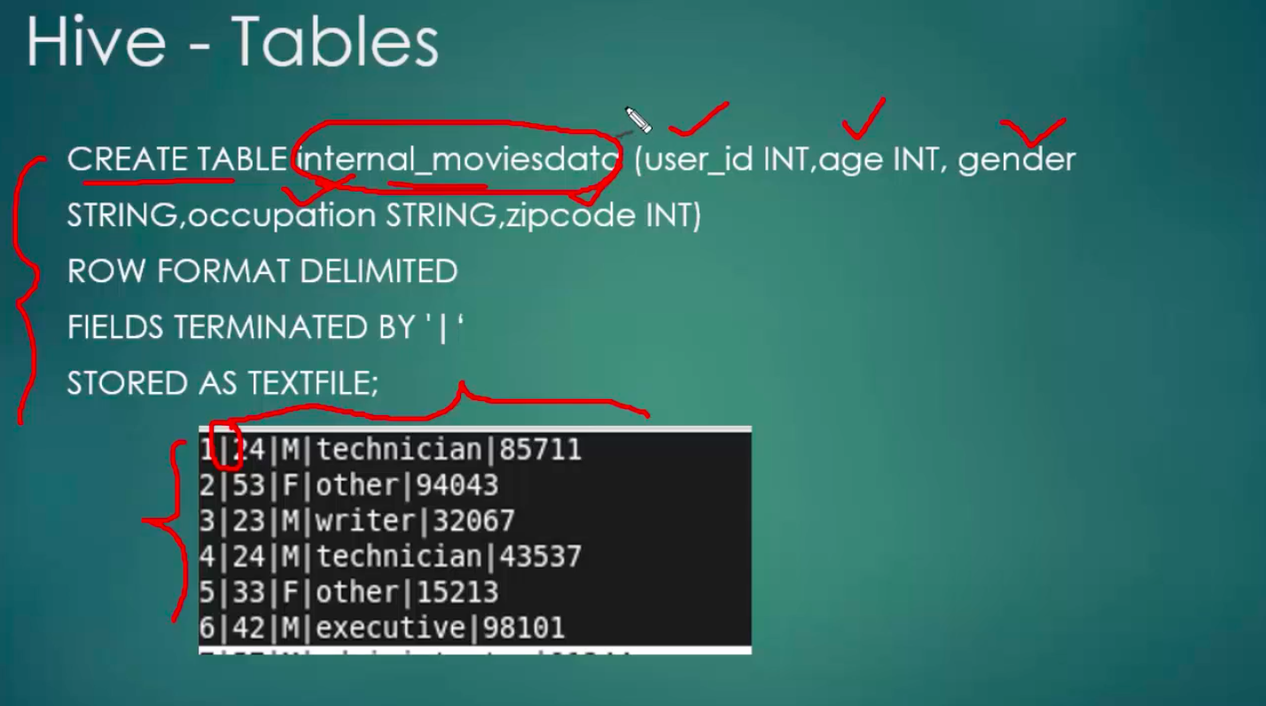

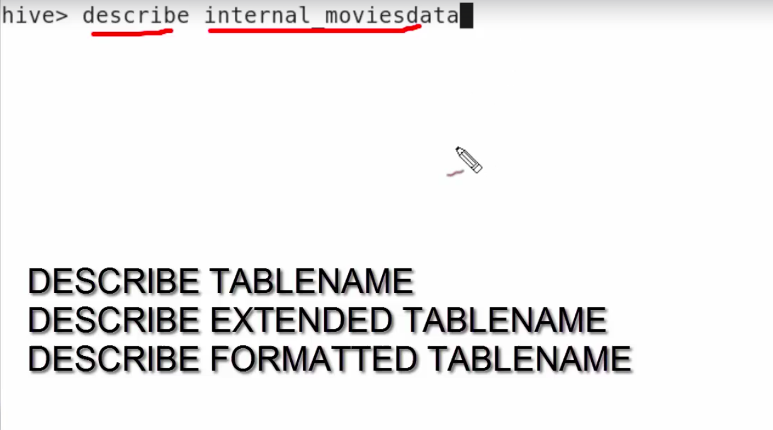

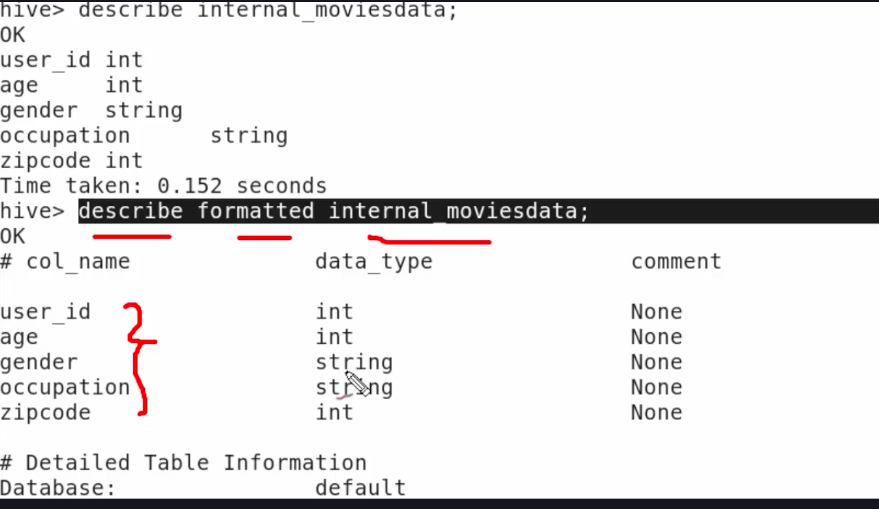

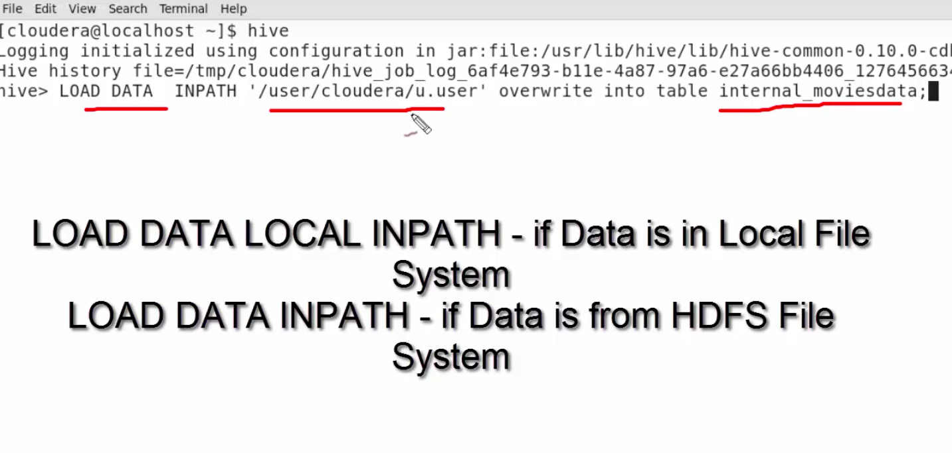

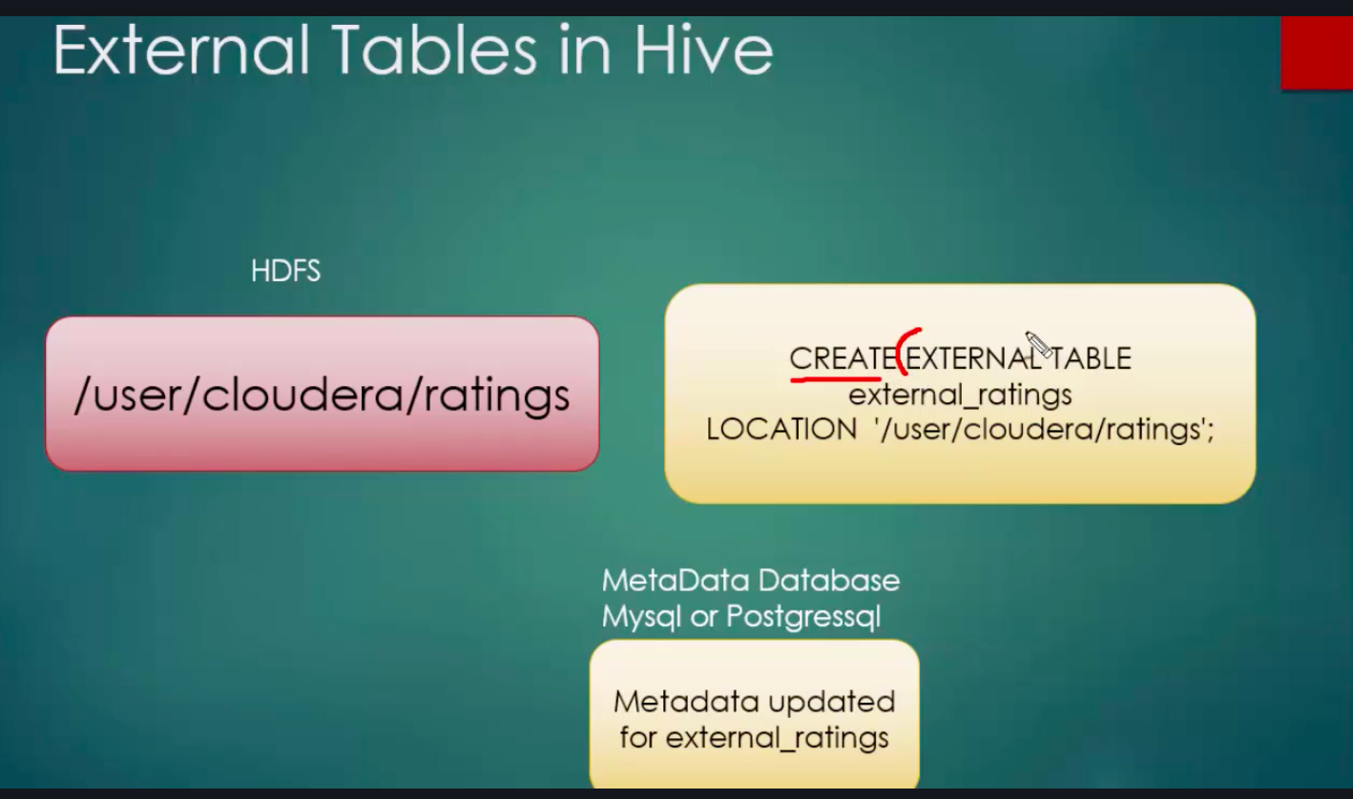

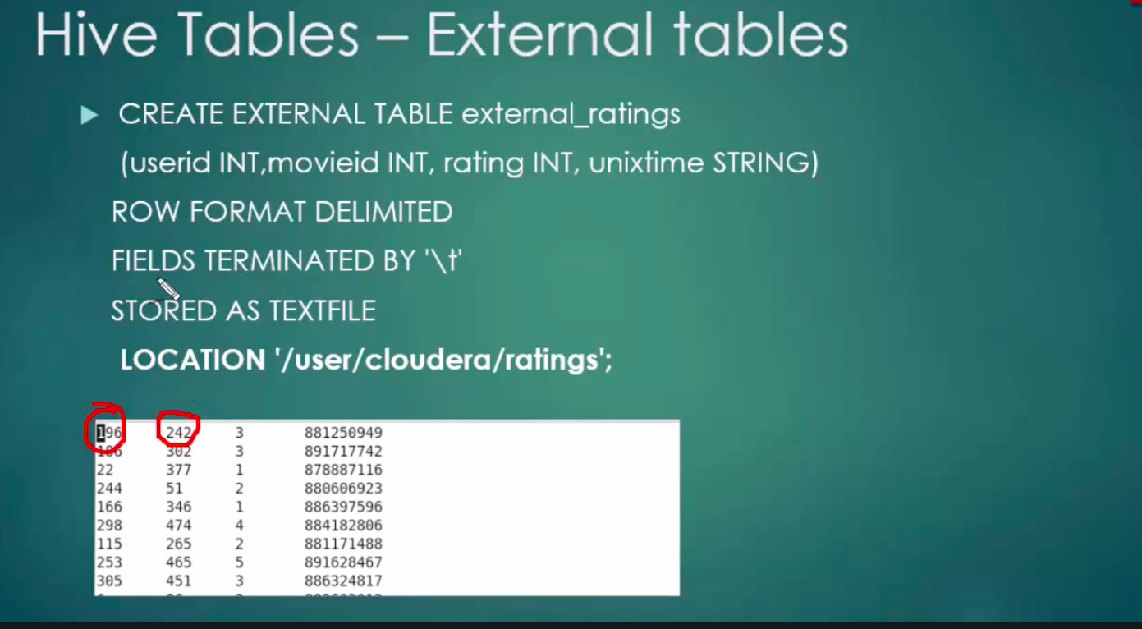

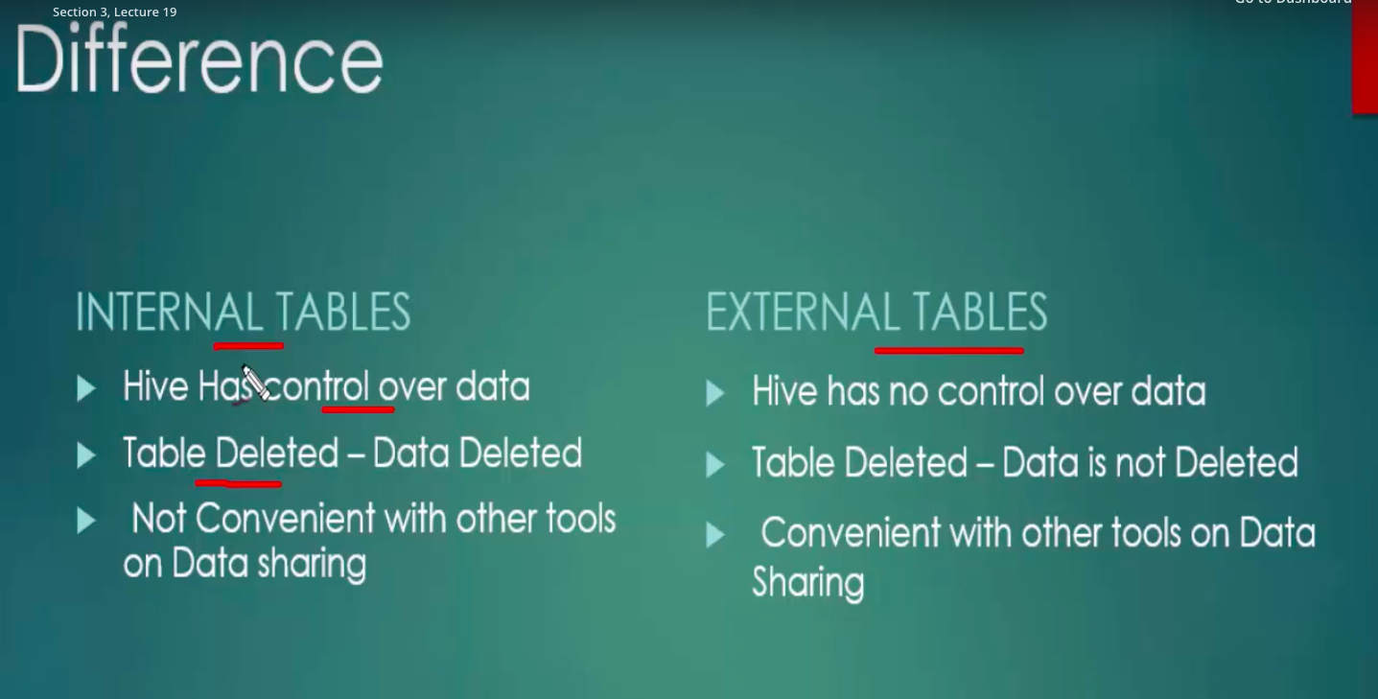

partitioning

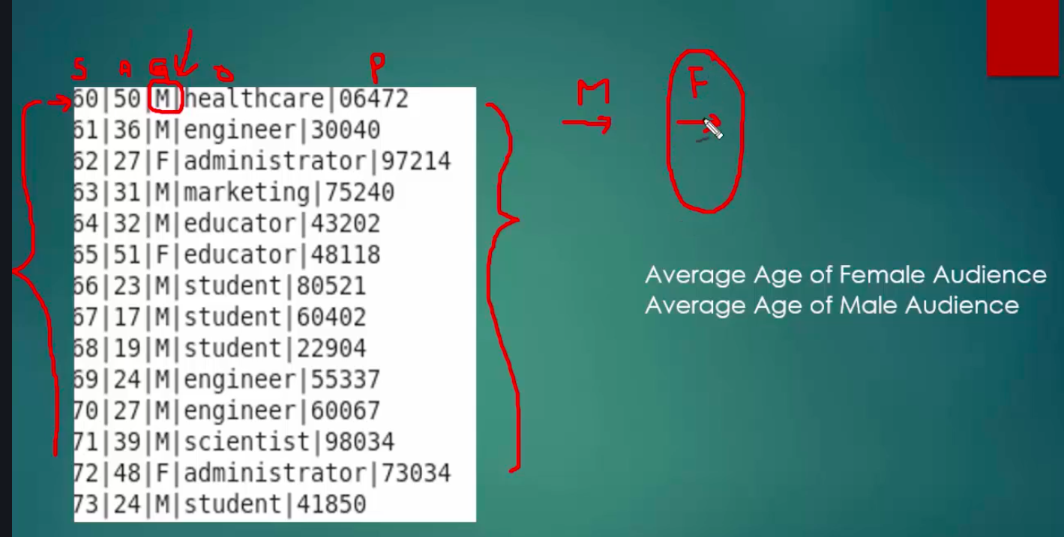

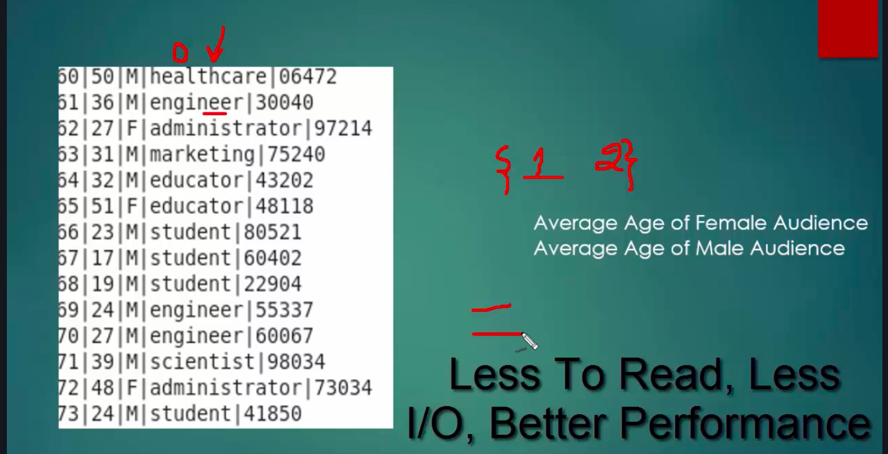

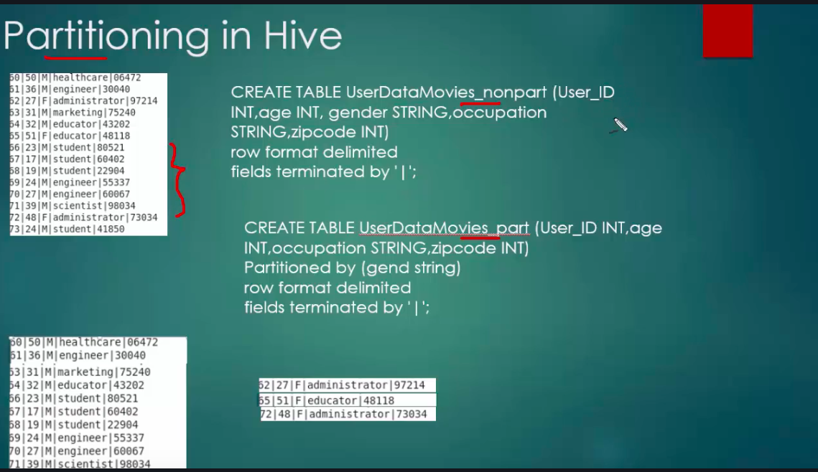

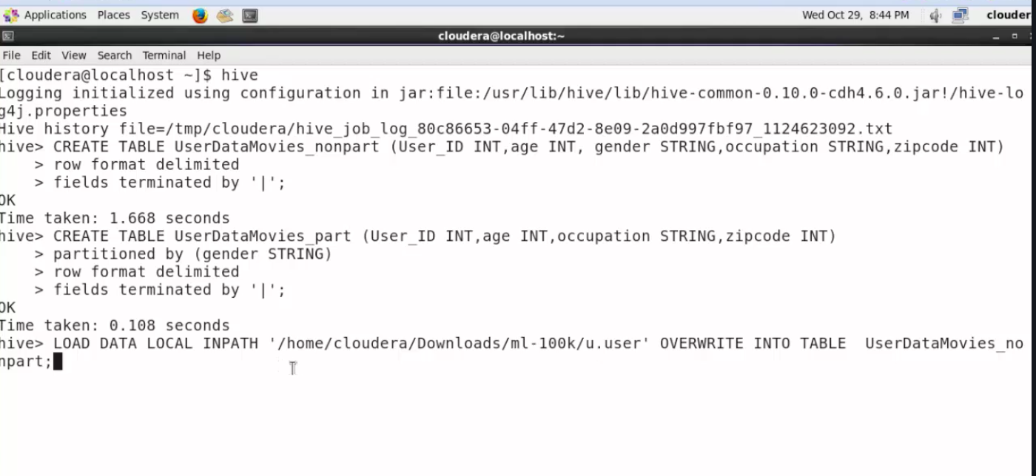

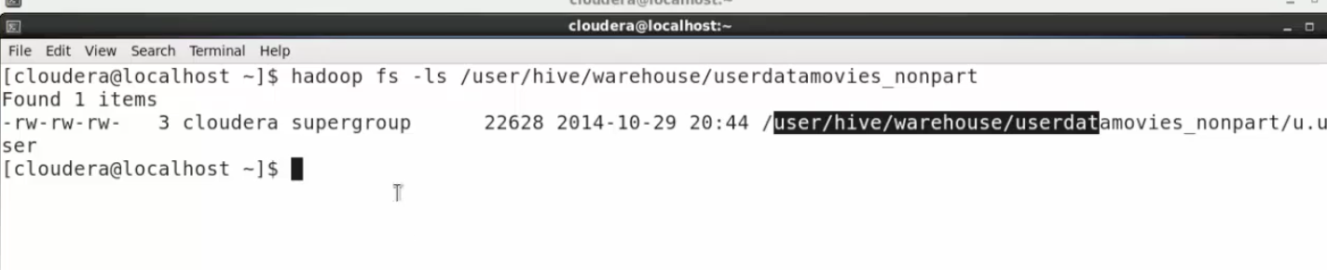

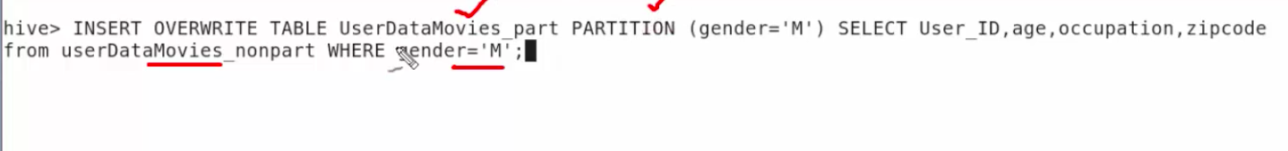

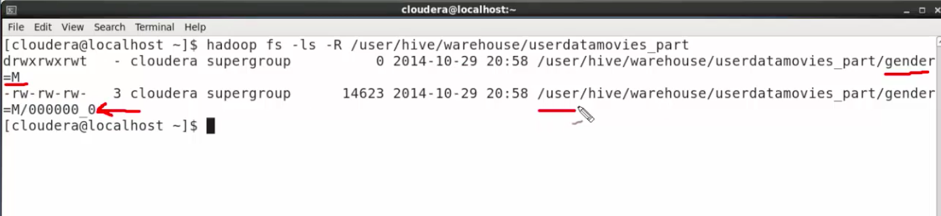

**Bucketing :-**

Bucketing creates files rather than folders in partition.

Its more relevant in cases where there are too many unique values for a column and partitioning will lead to creation of too many folders .Both are forms of partitioning only .

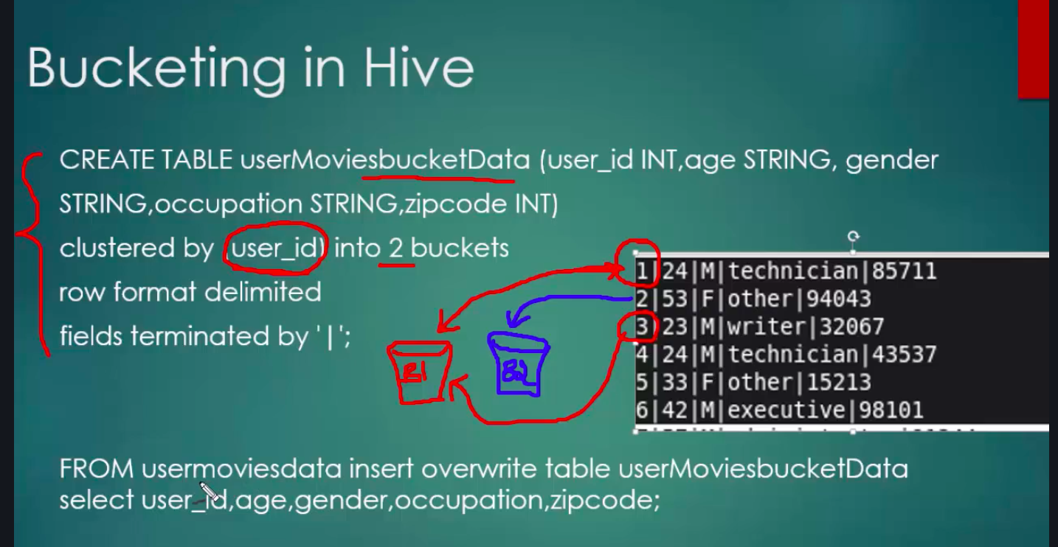

As we can see hash(user_id) will decide which bucket the row will go into.

Important thing to note before using bucketing is :- run the command

Hive > set hive.enforce.bucketing=true

Also number of buckets signify the number of reducers too.

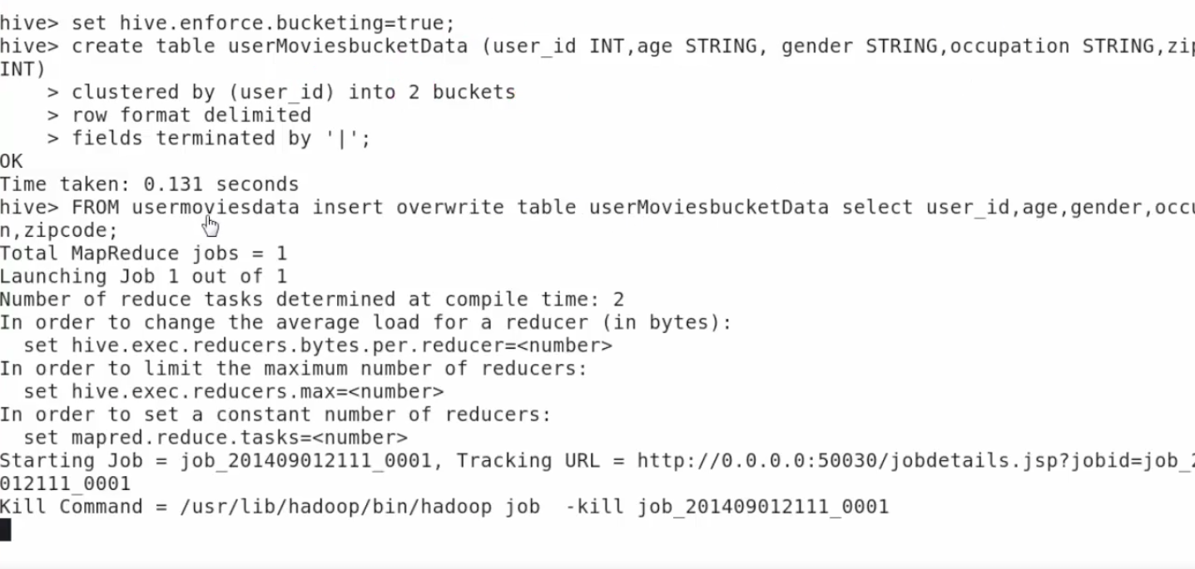

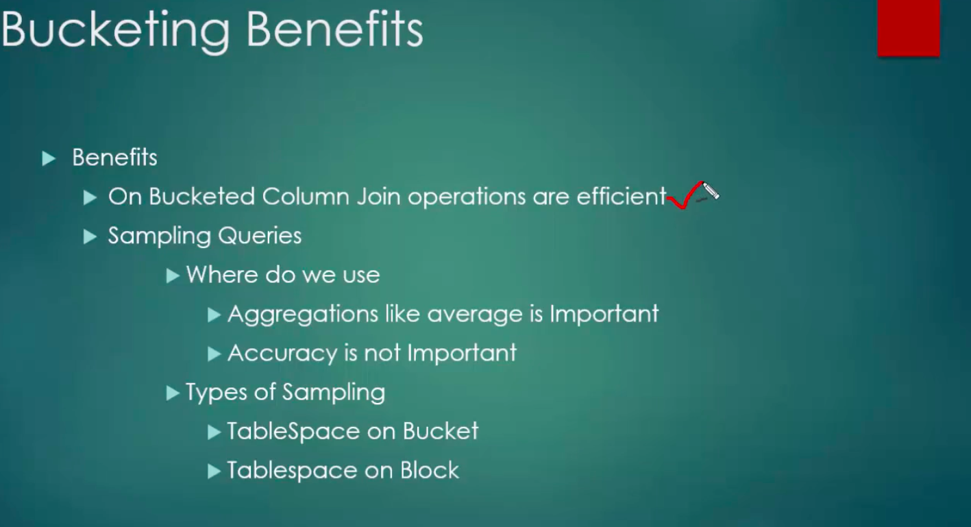

**Querying on bucket data :**



